1. 
2. Let us first go back to the very basics.
3. How Websites work?
4. A screen shot of a computer

   Description automatically generated
5. 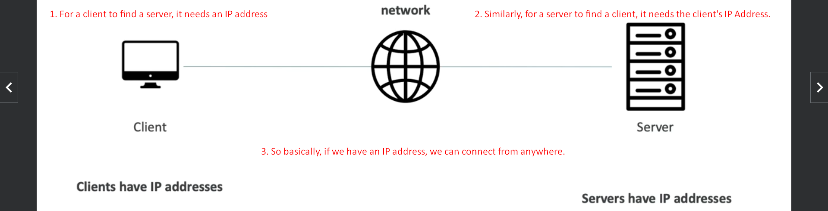  
   This is very similar to when we are sending a letter.

When we send a letter, we put the address where this letter should be delivered and our address on the back of the envelop.  
Here we are client, the letter is data and destination address is IP.  
Then we put the letter into mail box where the network of the Post Office will be the network.

Then the Post Office will use its network and the address to route the letter to the destination (server).  
If the recipient wants to reply, they can use your address on the back of the envelop.  
So, servers are just like the network of your mail.

1. A grey mailbox with a red handle

   Description automatically generated
2. A screenshot of a computer

   Description automatically generated
3. A diagram of a computer network

   Description automatically generated  
   let’s go back to Traditional IT.  
   When people used to start websites or companies before, they used to do it their home or their Garage.  
   So, they will literally go to their store, buy a server and put the server in their home.  
   You know Google started in a Garage.  
   As you add more and more servers to serve the demand and so your home starts to be filled with servers.  
   As your company getting bigger and generating a huge money, so you going to move to your own office and you decide to allocate a special room which is going to be called a Data Center having servers and you keep on adding more and more servers as demand increases.  
   This way served for so many years.

